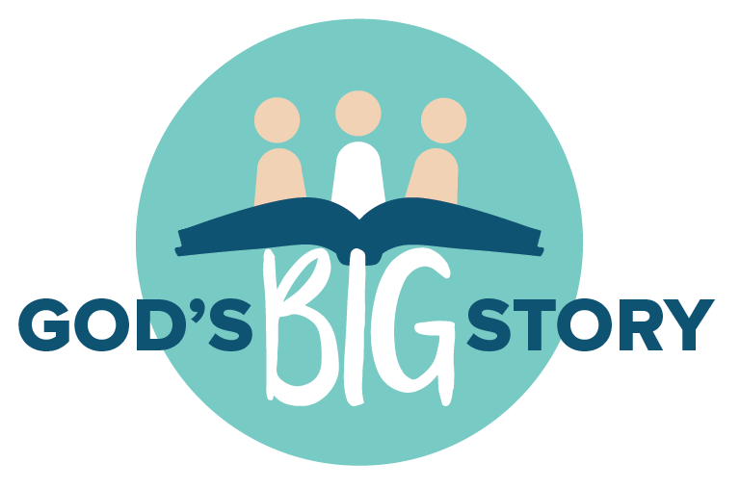

WHAT IS THE GOSPEL?

What is the gospel?

Question: What is the gospel?
Answer: The gospel is the good news
of God loving and saving his people
through his Son, Jesus Christ.

To understand the gospel we need to look at God’s Big Story from beginning to end.

God’s Best Way to Live
The Bible declares that God created the heavens and the earth.
He made everything and best of all he made people in his image.
When God looked at everything he made he said “it is very good!”

Adam and Eve lived in perfect friendship with God and with each other. God loves us and he wants to live in perfect friendship with every person that he has lovingly created in his image.

Saying NO to God
Adam and Eve had everything they needed to be happy. But they chose to disobey God’s word and when that happened sin entered God’s perfect creation. Sin is the bible’s word for saying NO to God and going my own way. Sin separates me from God, which makes God very sad. Every person who ever lived is infected by sin.

The Problem of Sin
Every part of God’s creation has been touched by sin. Each one of us is guilty before God the Judge. Even if we try to do the right thing, sin is too strong for us to beat on our own. We can never work hard enough to get things back to the way they were in the beginning. Working hard and doing good isn’t enough to fix our broken friendship with God or with one another. We need help!

God’s Rescue Plan
God had a plan from the very beginning to fix this very BIG problem! God sent his Son Jesus to rescue us from sin. Even though Jesus didn’t sin or do anything wrong, he died in our place so that our sin is forgiven and we can be friends with God again. Jesus is the Good Shepherd who lays his life down for the sheep. This is very good news!

“Christ didn’t have any sin. But God made him become sin for us. So we can be made right with God because of what Christ has done for us.” 2 Corinthians 5:21

“For God so loved the world that he gave his only Son so that whoever believes in him will not perish but have eternal life.” John 3:16

Jesus the King!
After three days, Jesus rose from the dead! When Jesus rose again, he showed that he’s stronger than death and proved that ALL God’s promises come true in Jesus.

When we say sorry to God and put our whole trust in Jesus, he gives us the same new life that he has. He washes us clean and gives us the gift of eternal life which begins NOW as we follow Jesus day by day.

Following Jesus
Following Jesus starts with two things: Repentance and Faith. Repentance means turning away from sin and towards God. Faith means trusting in Jesus as my Rescuer and King. They’re always two sides of one coin—like heads and tails!

Following Jesus means knowing that he is always with me. He is my Lord and Saviour and I am a child of God. He gives me the Holy Spirit as a Helper to change my heart and make me more and more like Jesus. I’m not perfect—I still sin. But sin doesn’t rule over me anymore! God has given me his word, the Bible to help me follow Jesus. He speaks to me when I read it, and he loves it when I speak to him in prayer.

And one day, King Jesus is coming back to judge the world. When he comes, everyone who trusts in Jesus will be with him forever. That will be the best day ever and it will continue for eternity!

Have you ever told Jesus that you want to follow him?

If you’ve heard the good news of who Jesus is and what he has done for you and you want to follow Jesus as your Lord and Saviour all you have to do is talk to him about it.

Jeremy Graham
St John’s Vancouver

